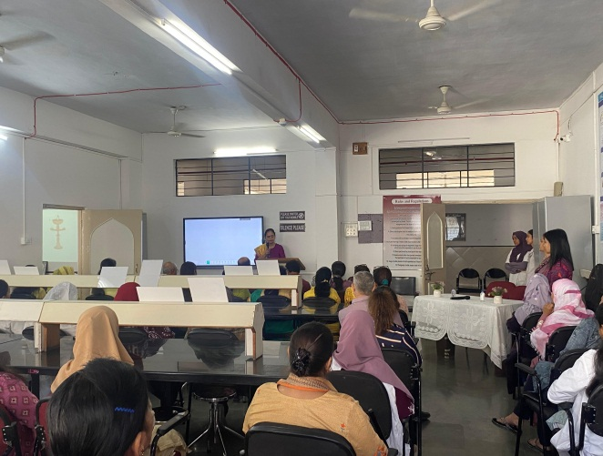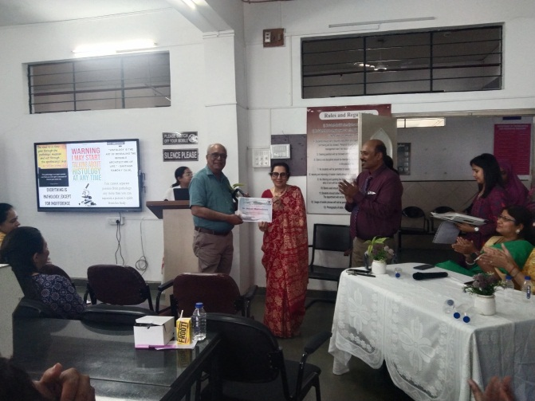

CERVICAL CANCER AWARENESS

**Faculty Development Program Cervical Cancer Awareness**

**Felicitation of the speaker**

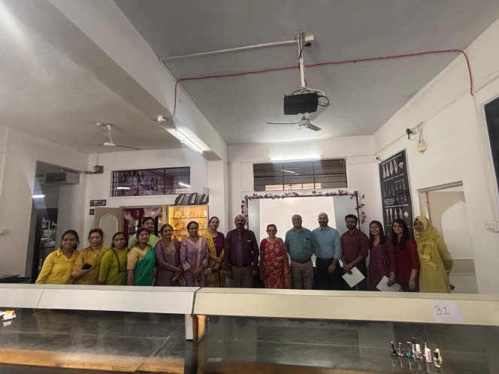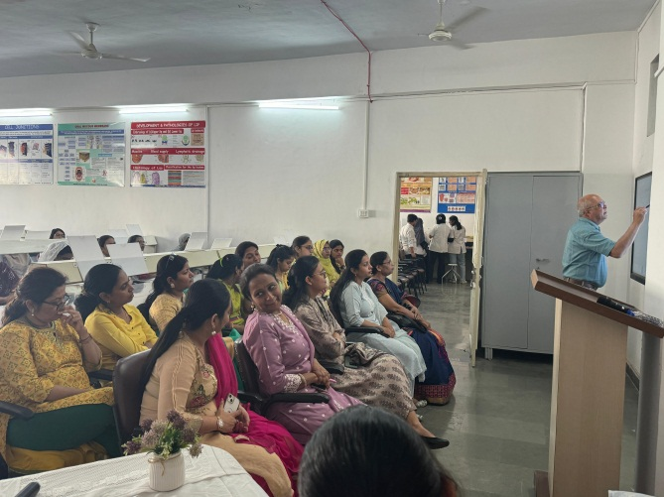

**All faculties with the speaker**